Inventory Sheet and Label Instructions – SAA Holiday Market 2021
Inventory Sheet:
Please complete the SAA Holiday Market 2021 Inventory Sheets as described below. You may use as many sheets as you need to document your inventory. A blank inventory form was included in the email you received with these instructions.
PLEASE NOTE THAT WE HAVE MADE A CHANGE TO THE INVENTORY SYSTEM FROM PREVIOUS YEARS. Inventory IDs will now be all LETTERS, and NOT NUMBERS. This decision was made to help us avoid the most common error we see, costing both our artists and our customers money. Thank you in advance for your attention!
We recommend you enter your inventory by typing it into the form, then print it out to submit it to the market. It is much easier to read if it is typed. If you must handwrite the form, please make sure it is legible.
Top Section: Enter your personal information. Please only use first and last initial unless otherwise instructed.
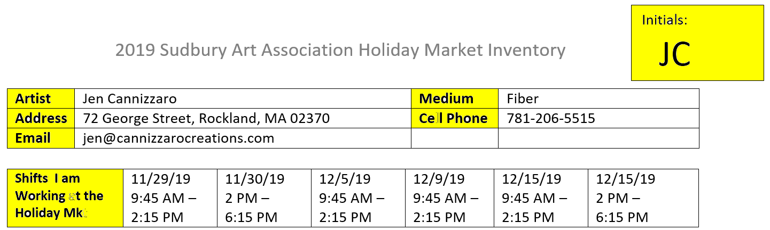
Inventory: The Inventory section consists of 3 columns:
- Item ID - the item ID consists of your initials, a dash, and a letter (or letters). The item IDs must be in alphabetical order and will be added to the label identifying your items. (See section on labels, below, for more information). If you run out of letters, you can use doubles, e.g. JC-AA, JC-AB, etc.
- Item description – description of the item, please be specific
- Price Each – enter the price for each item. In the example below, I am selling single coasters for $4 each. I am also selling sets of 4 coasters for $15 a set. Each single coaster will be marked with a JC-A label and each set of 4 coasters will be marked with a JC-B label.

If you are going to have ‘deals’, such as the set of 4 coasters for a better price than buying singles, your items MUST be packaged and labeled as such. Each item must have 1 label detailing its item ID and price. We cannot expect our fellow artists to know special pricing for everyone’s items. If I am selling single coasters, each single coaster should have a JC-A tag on it. If I am selling a set of 4 coasters, the 4 coasters must be packaged together with a JC-B tag on them.
You may use as many inventory sheets as you need, just continue the item IDs onto a second page.
Labels:
Removable labels must be attached to each item you are selling. When an item is sold, the label is removed from your item and attached to the sales slip so you get credit for the sale (artists that are selling jewelry may use stringed paper tags that can be cut from the item and taped to the sales slip). The label must contain the Item ID and the Price. Here is an example:
JC-A
$4

Many artists use Avery labels 5418. You can purchase these labels online or at Staples or Office Max. Avery also has a template you can use to feed the labels through your printer.
NOTE: If you sell non-taxable items, such as clothing, please highlight the label of your non-taxable items in yellow highlighter. This will help our fellow artists charge our customers appropriately.
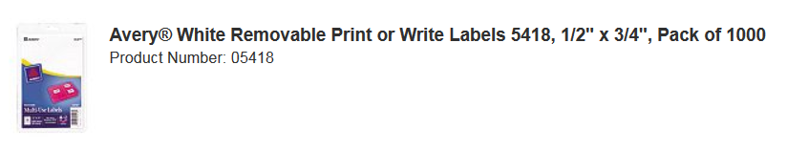

YOUR ITEMS MUST BE LABELED AS DESCRIBED IN THIS DOCUMENT. If your inventory currently has labels that do not follow the guidelines in this document, they must be removed from your items. We all need to follow the same format so we can keep our bookkeepers from doing extra work. Thank you in advance!

